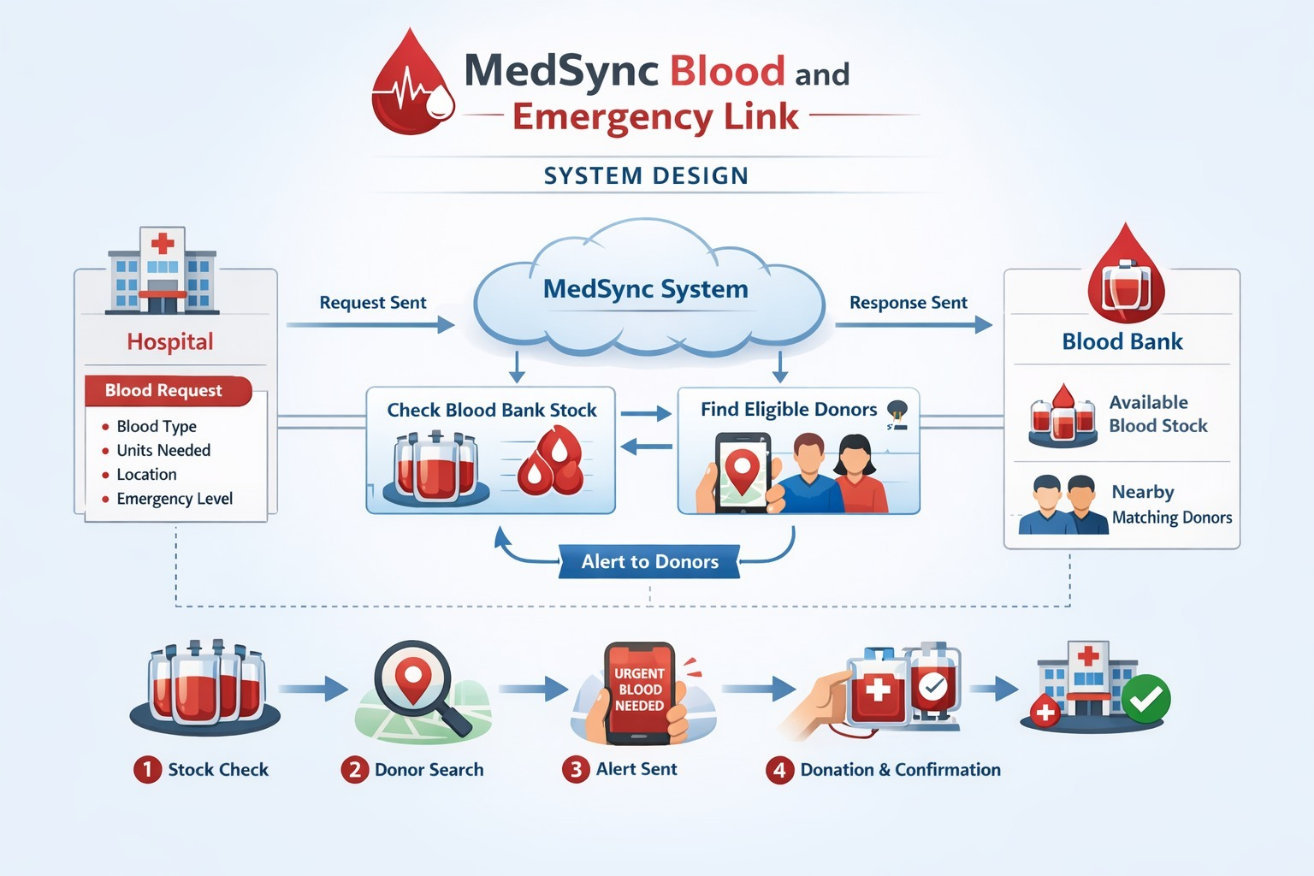

This is a system design of MedSync Blood and Emergency link

